To launch the Project Unity hub must be downloaded.
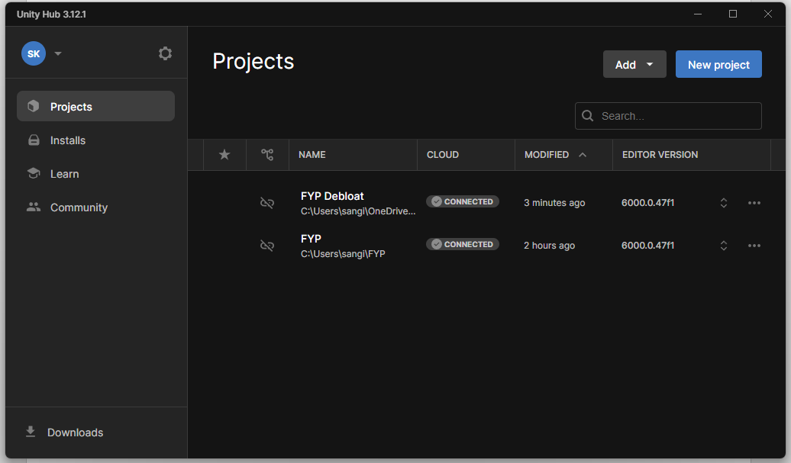
- Press on Add dropdown,
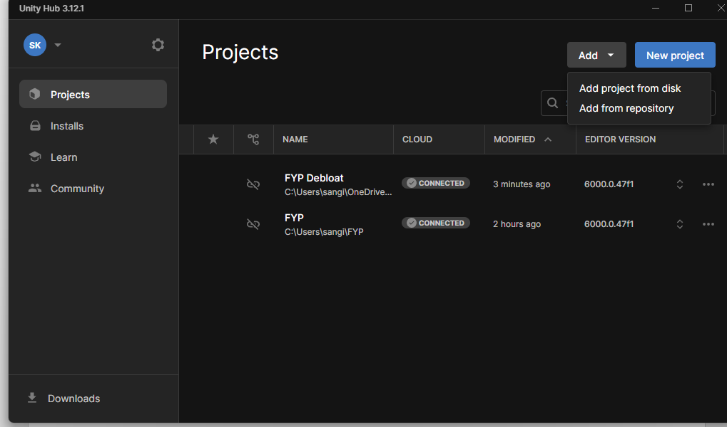
- Choose Add project from disk.
- Navigate to the project folder and choose open.
- If the unity version is not installed install it and open the project from the hub.
- After the project opens
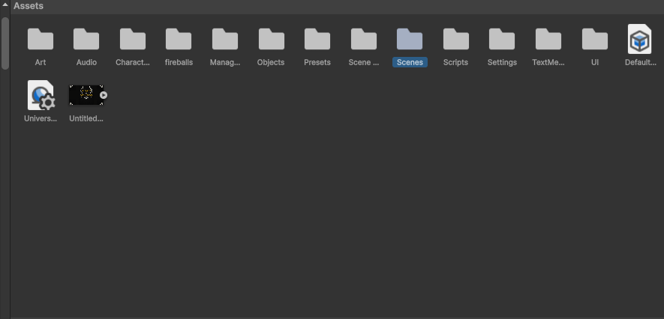
- Navigate to the Scenes folder in Assets.
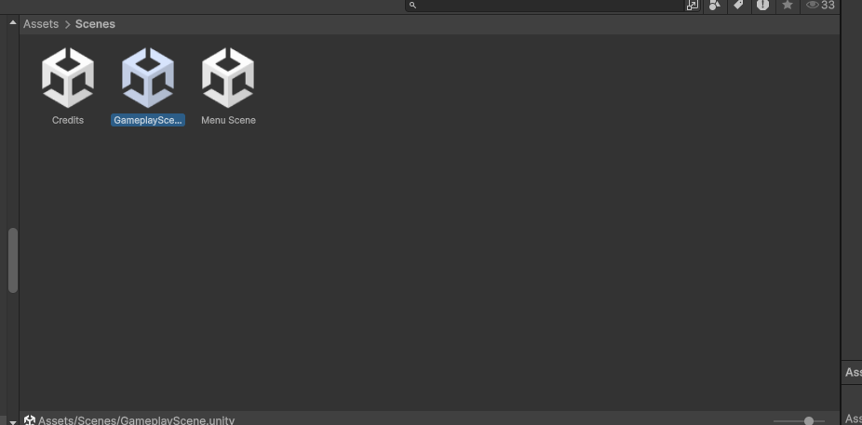
- Choose and double click on gameplay scene.
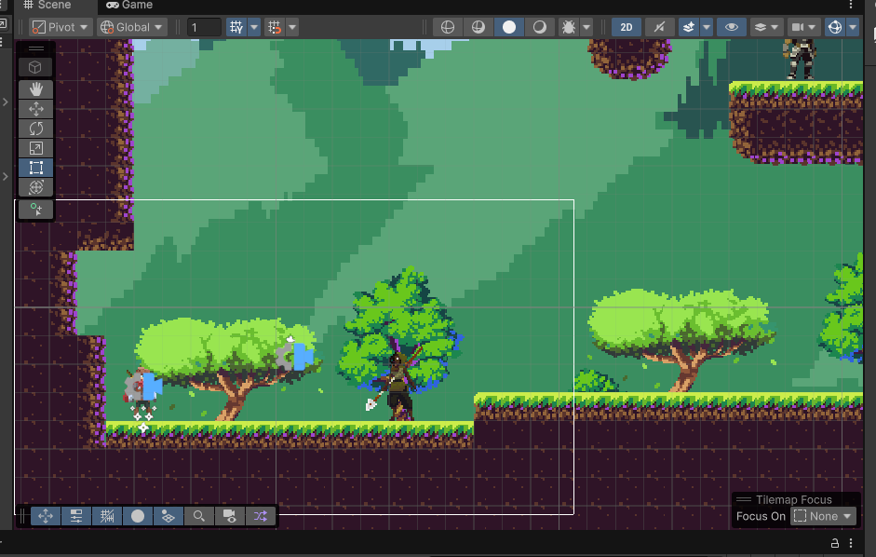
- After that the gameplay scene opens up.
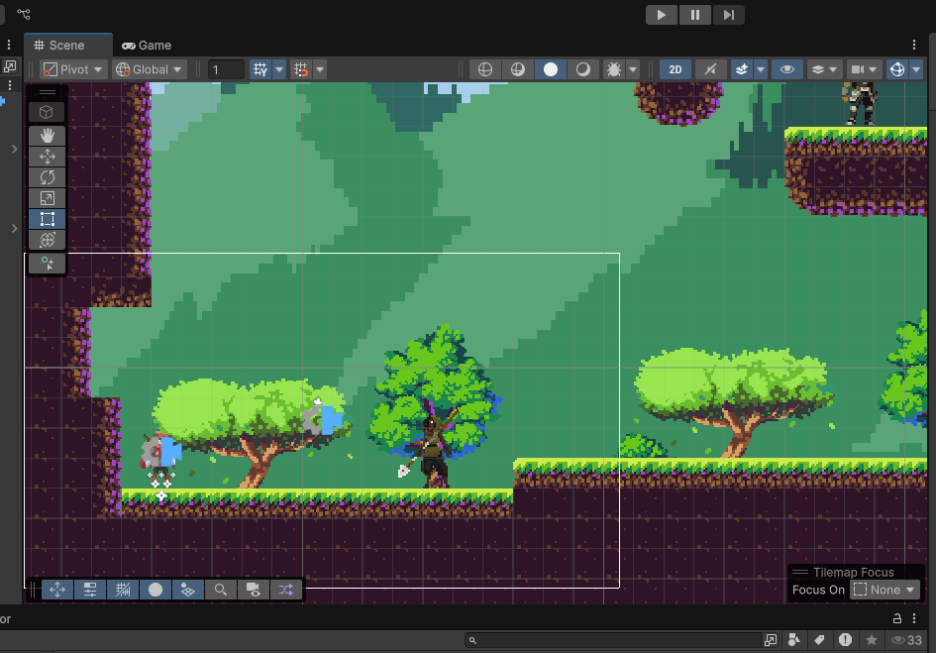
- The game can be played from using the play button on top of the scene view.
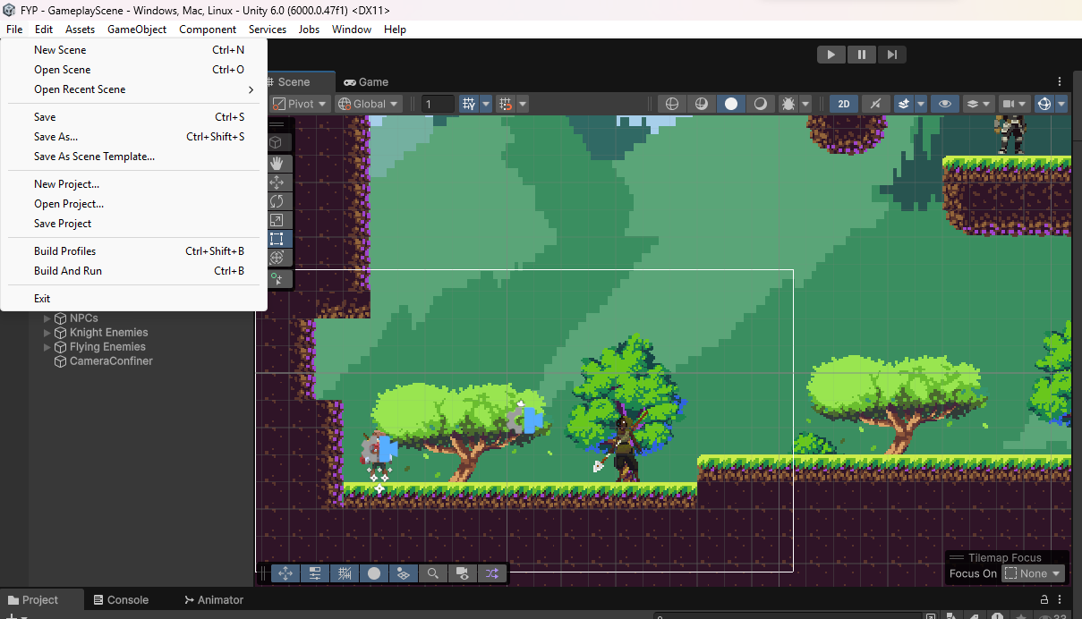
- To export the game build chose file from the options.
- After that choose build and run option, and the game build begins.

